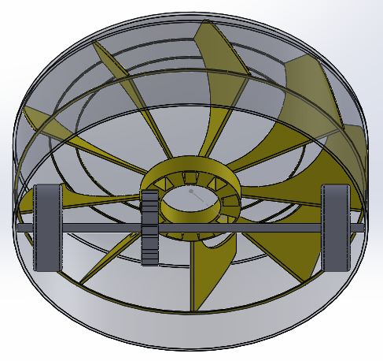

Figure 2: This view from bellow the front of the mechanically powered vacuum illustrates the driving mechanism that will power the fan. The fan sits below the dust bin (not yet modeled). Also, here you can see how the top cover, will rest on the main axle.
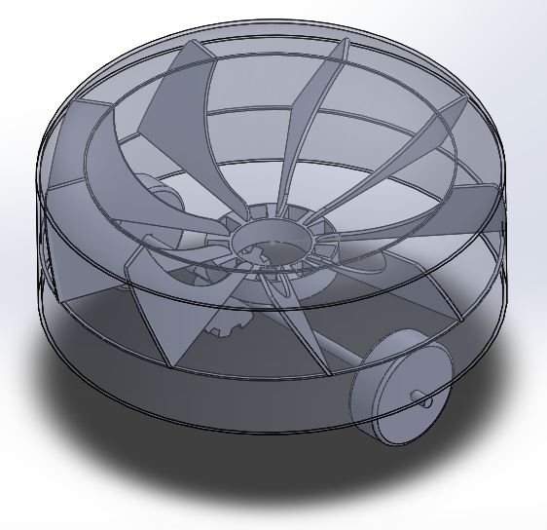
Figure 1: An isometric view of the mechanically powered vacuum cleaner. The top cover has been made transparent to allow view of the internal mechanisms. The internal fan is still going under heavy development, and is only made possible by recent advancements in 3d printing, which will allow us to create highly customized parts.
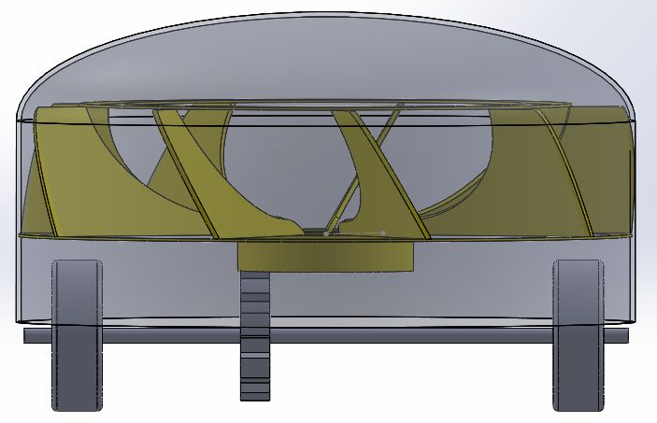

Figure 3: Figure 3 is a profile from the front. Here you can get an idea of the dust bin capacity, which will rest, inside the yellow fan blades. Also from this view one can clearly see the possible gear ratio attainable. The gear diameter is limited by the wheel diameter. So to maximize suction the fan blades have been re designed to maximize area on the outside.

